**Zero** is a 2018 Indian Hindi-language romantic drama film written by Himanshu Sharma and ... This love triangle takes them to far-off **cities**, and thrusts Bauua into an ..... In the behind-the-scenes video of the making of the song "Mere Naam Tu," Anushka Sharma **details** the video in a voice-over, and she mentions several ...

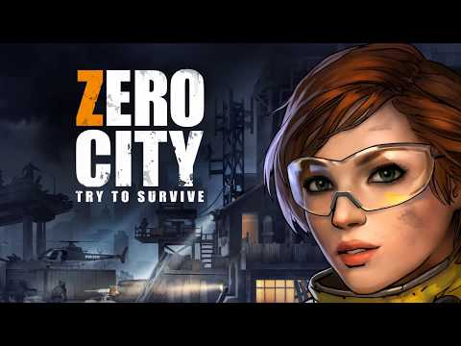

System requirements

|  |  |
| --- | --- |
| **Operating System** | **Windows 8.1 64-bit or later** |
| Processor | Intel i7/i9 processor 2.5 GHz or faster |
| RAM | 16 GB or more |
| Hard disk space | 25 GB dedicated for software installation |
| Graphics card | NVIDIA 1080 for Desktops NVIDIA 1070 for Laptops |