Confident in his powers as Spider-Man, Peter Parker (Andrew Garfield) embraces his new role as a hero and spends time with Gwen Stacy (Emma Stone) in between protecting New York from criminals. However, his greatest battle yet is about to begin. With the emergence of Electro (Jamie Foxx), Peter must confront an enemy far more powerful than he is. And when his old friend Harry Osborn (Dane DeHaan) returns, Peter comes to realize that all his enemies have one thing in common: Oscorp.

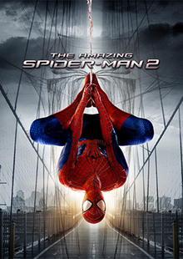

**The Amazing Spider**-**Man 2** needs a Radeon HD 4770 512MB graphics card to play on low settings, with a Core **2** Duo E4700 2.6GHz or Athlon 64 X2 Dual Core 3800+ processor to reach the**minimum specs**, achieving 30FPS on 1080p monitor res. You should also have 3 GB **system** memory for min **specs**