**Payback 2** is a role-playing video game, developed and published by Apex Designs. It was released on November 20, 2012 for Android and iOS. It is a sequel to "one of the first Grand Theft Auto-style games". It became free to play in 2013

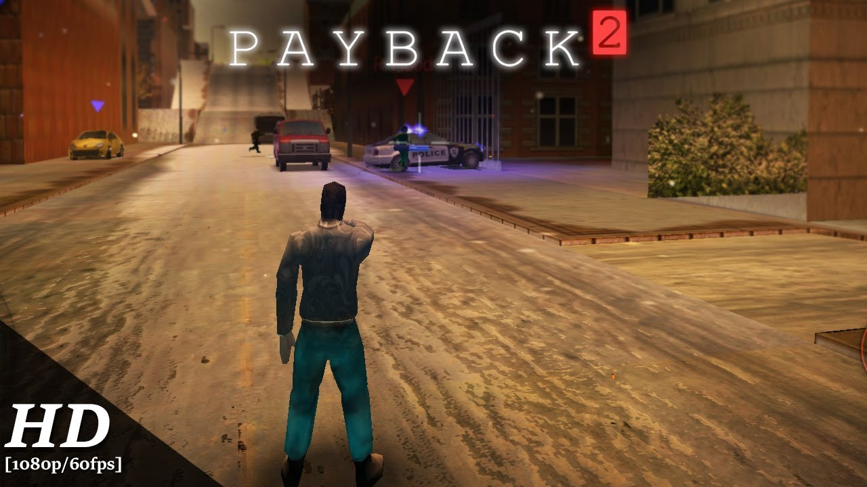

**PAYBACK 2** game details

An Intel Core **2** Duo E8190/Athlon X2 7850 and a GeForce GTX 260/Radeon HD 6770 will get you ready for crime.