**James Bond 007**: **Blood Stone** is a third-person shooter video game, developed by Bizarre Creations and published by Activision for the Microsoft Windows, Nintendo DS, PlayStation 3 and Xbox 360 platforms. ... **Blood Stone** features the voices and likenesses of Daniel Craig, Judi Dench, and Joss **Stone**.

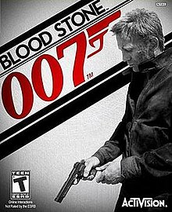

**James Bond 007 Blood Stone Minimum Requirements**:

Processor: Intel® Core™ 2 Duo E4300 1.80 GHz. RAM: 1 GB (Windows XP), 2 GB (Windows Vista and 7) Graphics: NVIDIA GeForce 7600 GT+, GeForce 8600 GT+ DirectX: Version 11.