**Free Fire** is the ultimate survival shooter game available on mobile. Each 10-minute game places you on a remote island where you are pit against 49 other players, all seeking survival. Players freely choose their starting point with their parachute, and aim to stay in the safe zone for as long as possible.

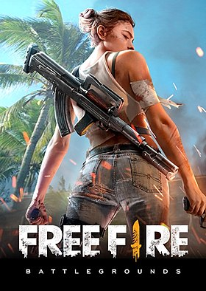

**Here's what you need to run Free Fire Game on your PC.**

* OS: Windows 10, Windows 8.1, Windows 8, Windows 7, Windows Vista SP2 , Windows XP SP3 (32-bit only)
* Processor: Dual Core 2+ GHz.
* Memory: 2 GB RAM.
* Graphics: Nvidia HD Graphics 3000 or Higher.
* DirectX: Version 11.
* Storage: 4 GB available space.